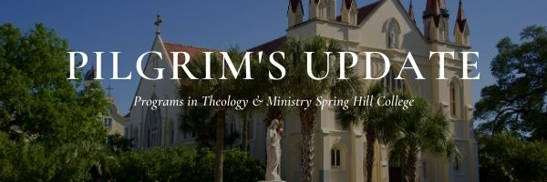

Greetings! Here in Mobile, AL, the azaleas are already blooming, the trees are popping with little buds, the grass is turning green again, and the birds are chirping good morning; it is spring! We have some important announcements to share with you.

Dr. Matthew Bagot will be presenting a paper entitled, “Enhancing Democracy: The Mutual Contribution of Catholicism and Reformist Islam on the Vital Significance of Human Rights” at Societas Ethica’s 60th Annual Conference 2024 in Uppsala, Sweden august 22-25. The Conference is entitled Human Rights—Critical Perspectives. Matthew has also received a Mitchell Award from Spring Hill College. We are proud of Matt!!

Congratulations to Dr. Steve Wilson, who has been promoted to the position of Professor of Theology. Steve will be the Division Chair of the Philosophy & Theology starting this July.

Our course schedule for the 2024-2025 academic year will be posted on our website <https://www.shc.edu/academics/theology-graduate/> by mid-April. I plan to talk with you before registration starts soon to increase the number of students registering for classes next academic year.

The Christus Hesburgh Lecture titled "Can You Do Well By Doing Good? A global Initiative, A Global Agenda" will take place on **Wednesday, April 4 2024, at 7:00 PM**. The lecture will be held at Byrne Memorial Hall, Spring Hill College, and delivered by Fr. Oliver Williams, C.S.C., Professor of Theology at the University of Notre Dame. All are welcome to attend this event.

Summer Institute of Christian Spirituality will take place Monday, June 3 – Friday, June 14, and the 3, 5, or 8-day Silent Ignatian Retreat is Friday, June 14 – Saturday June 22. Registrations will be open soon.

The contact information for the Graduate Theology office is [theology@shc.edu](mailto:theology@shc.edu), and the phone number is 251-380-4665. We would love to hear from you if you have any news to share with our students and alumni. Please send it to Sr. Nélida Naveros Córdova at [nnaveroscordova@shc.edu](mailto:nnaveroscordova@shc.edu).