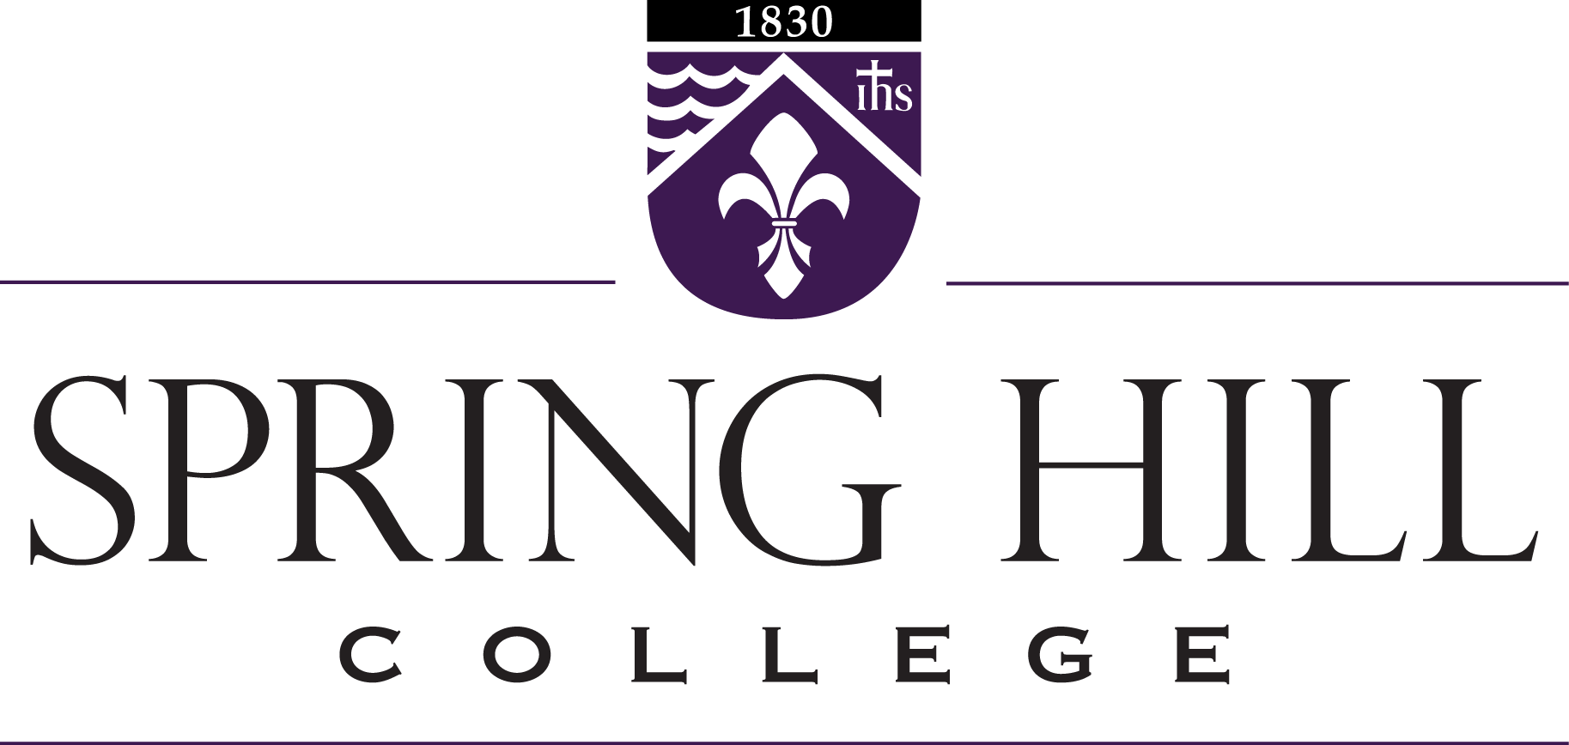

**Division of Education**

**Accountability Measures**

**Continuous Improvement Plans**

**Annual Report - 23-24**

| ***Measure 1:***  **Completer Effectiveness** | **Educator Preparation Institutional Report Card and Responses to First-Year Teacher Survey**  (Provided by the State of Alabama)  <https://www.alabamaachieves.org/wp-content/uploads/2025/03/RD_ED_2025313_2024-HERC-Annual-Data-Spring-Hill_v1.0.pdf>  **EPP Employer and Completer Case Study**  *See attachment:*  “Spring Hill College CAEP Standard 4: Program Impact Narrative”  In response to the lack of data available to the EPP for this CAEP measure, the EPP is actively working with local education agencies and the Alabama State Department of Education to collect additional data, which include student test scores and teacher evaluations, to sufficiently address Completer Effectiveness and Impact on P-12 Learning and Development. Additional data is being collected now by all EPPs in the state of Alabama and by the Alabama State Department of Education.  **Continuous Improvement Plan:**  *Data:*  18% disagreed in state-wide data that they were prepared to understand Alabama’s state assessment program. Additionally, first-year teachers did not feel prepared to incorporate assessment practices into daily curriculum routines.  *Action:*  The EPP plans to implement additional key assessments across Teaching Field courses to increase students’ understanding and application of assessment practices during field experiences.  *Measurement:*  The EPP will measure the effectiveness of these key assessments by reviewing the First-Year Teacher survey and will strive to decrease this amount of disagreement by First-Year teachers by 5%. |
| --- | --- |
| **Measure 2:**  **Satisfaction of Employers and Stakeholder Involvement** | The EPP has developed working relationships and pursued new partnerships from area school districts involved in the continuous improvement (CI) process. The EPP holds regular meetings to engage in discussions in which the stakeholders provide feedback which leads to actions and improvements for the EPP.  ***Clinical Partners***  School partnerships are vital to the success of the EPP. Local school district representatives provide ongoing support and feedback to enact changes through our continuous improvement process including direct feedback to our teacher candidates as they engage in school-based experiences and semester-long internships.. Our Advisory Committee, which is comprised of classroom teachers, school district personnel, and college faculty/staff, discuss issues related to field experiences/clinical practice and assessments and provide recommendations and feedback to EPP leadership.    ***School-Based Mentor Teachers***  School-based mentor teachers are partners in the candidate’s clinical experiences throughout their programs. During the teacher internship (student teaching) the role of Cooperating Teacher is critical to the success of the candidates as they support candidates in planning, instruction, and assessment of students.  ====================================================  **EPP State Report Card**  <https://www.alabamaachieves.org/wp-content/uploads/2025/03/RD_ED_2025313_2024-HERC-Annual-Data-Spring-Hill_v1.0.pdf>  **Continuous Improvement Plan:**  *Data:*  48% in state-wide data indicated that they were prepared to understand and implement requirements of Alabama’s state initiatives. This percentage indicates opportunities for improvement.  *Action:*  The EPP plans to implement partnerships with Alabama state initiatives including ARI, AMSTI, and EL offices to increase participation in professional learning sessions regarding the Alabama Literacy Act and Alabama Numeracy Act.  *Measurement:*  The EPP will measure the effectiveness of these professional learning sessions by requiring 100% attendance of EPP teacher candidates and 85% passing rate on the Foundations of Reading test from EPP teacher candidates. |
| **Measure 3:**  **Candidate Competency at Completion** | **EPP State Report Card**  <https://www.alabamaachieves.org/wp-content/uploads/2025/03/RD_ED_2025313_2024-HERC-Annual-Data-Spring-Hill_v1.0.pdf>  **edTPA Passing Rates**  (For information about edTPA, please visit [https://www.edtpa.com](https://www.edtpa.com/))  **2023-2024 edTPA Summary Statistics**  The following data was pulled from the EdReports website using the ResultsAnalyzer Test Data. The data represents statistics calculated from Best Attempt Scores.  **Elementary Education: Literacy with Mathematics**  **18 Rubric Handbook**  **Cut Score: 44**  **Year 2023-2024**   | **Year 23-24** | **Number of Candidates** | **Mean Score** | **% Pass Rate** | **Number Passed** | | --- | --- | --- | --- | --- | | **National** | 6,542 | 51.8 |  |  | | **State** | 983 | 53.2 | 97% | 975 | | **SHC** | 7 | 52.7 | 100% | 7 |   **Secondary Education: English Language Arts**  **15 Rubric Handbook**  **Cut Score: 37**  **Year 2023-2024**   | **Year 23-24** | **Number of Candidates** | **Mean Score** | **% Pass Rate** | **Number Passed** | | --- | --- | --- | --- | --- | | **National** | 9,366 | 44.3 |  |  | | **State** | 781 | 44.8 | 97% | 760 | | **SHC** | 1 | 48 | 100% | 1 |  | **Rubric Number** | **Mean Score of All Candidates** | **Total Mean Scores by Cluster Area** | | --- | --- | --- | | Planning: Rubric 1 | 3.13 |  | | Planning: Rubric 2 | 3.00 |  | | Planning: Rubric 3 | 3.25 |  | | Planning: Rubric 4 | 2.75 |  | | Planning: Rubric 5 | 3.00 | 3.025 | | Instruction: Rubric 6 | 3.00 |  | | Instruction: Rubric 7 | 2.82 |  | | Instruction: Rubric 8 | 2.88 |  | | Instruction: Rubric 9 | 2.88 |  | | Instruction: Rubric 10 | 2.88 | 2.89 | | Assessment: Rubric 11 | 3.06 |  | | Assessment: Rubric 12 | 3.94 |  | | Assessment: Rubric 13 | 2.88 |  | | Assessment: Rubric 14 | 3.06 |  | | Assessment: Rubric 15 | 3.25 | 3.24 |   **Continuous Improvement Plan:**  *Data:*  The mean score of 2.89 in the cluster area of Instruction was the lowest mean score across all domains. The three rubrics we decided to analyze and work to improve included rubrics 7, 8, and 10. These areas require candidates to demonstrate student engagement strategies, strategies to deepen student learning, and analysis of teacher effectiveness (reflection).  *Action:*  The EPP plans to implement direct instruction in all literacy methods courses and in the foundations of curriculum course to provide students with better strategies for student engagement and deep student learning. Reflection tools will be introduced in the Junior Block methods courses to give students the opportunities to analyze teaching effectiveness in field experiences prior to beginning the edTPA assessment.  *Measurement:*  The EPP will measure the effectiveness of these actions by analyzing edTPA rubric scores in 24-25 to determine if the instructional adjustments in our methods courses increased rubric scores for rubrics 7, 8, and 10. Our goal is to achieve a mean score of 3.00 on each of these rubrics.  **Praxis Subject Assessments**  (For information on the Praxis Subject Assessments please visit:  <https://www.ets.org/praxis/about/subject?WT.ac=31040_praxis_about_praxisii>)  The following data was pulled from the ETS website using the Summary Report. The data represents statistics calculated from All Scores, meaning all attempts are represented, including multiple attempts from a single individual.  NOTE: * No data is displayed because the number of examinees is fewer than 5.  **5903 Elementary Education: 3 Subject Bundle-Mathematics Passing Score: 157**   | **Year 23-24** | **# of Examinees** | **Median Score** | **Mean Score** | | --- | --- | --- | --- | | **National** | 4594 | 162.00 | 161.34 | | **State** | 1446 | 159.00 | 158.60 | | **SHC** | 7 | 149.00 | 154.86 |   **5904 Elementary Education: 3 Subject Bundle-Social Studies Passing Score: 154**   | **Year 23-24** | **# of Examinees** | **Median Score** | **Mean Score** | | --- | --- | --- | --- | | **National** | 4780 | 156.00 | 158.22 | | **State** | 1446 | 159.00 | 158.60 | | **SHC** | 9 | 154.00 | 154.89 |   **5905 Elementary Education: 3 Subject Bundle-Science Passing Score: 158**   | **Year 23-24** | **# of Examinees** | **Median Score** | **Mean Score** | | --- | --- | --- | --- | | **National** | 4660 | 161.00 | 161.50 | | **State** | 1505 | 157.00 | 156.32 | | **SHC** | 9 | 164.00 | 161.44 |   **Continuous Improvement Plan:**  *Data:*  The mean scores of the Mathematics and Social Studies sections of the Elementary Education Praxis exams are below the state’s mean scores.  *Action:*  The EPP plans to implement conversations with faculty from our mathematics department and social sciences areas. Bringing an awareness of the standards addressed on these subtests can support our candidates in their core curriculum coursework at the college. Additionally, we plan to advise students into specific math and social science courses that we have learned best align to the Praxis standards. Review sessions will be implemented three times during each semester to support candidates' test preparation.  *Measurement:*  The EPP will measure the effectiveness of these actions by analyzing mean scores on the mathematics and social sciences sections during the 24-25 year in order to determine if our candidates’ mean scores have surpassed the state mean score.  **Foundations of Reading Passing Rates**  **(only for Elementary Education majors)**   | **Year 23-24** | **Number of Candidates** | **Mean**  **Score** | **% Pass Rate** | **Number Passed** | | --- | --- | --- | --- | --- | | **State** |  |  |  |  | | **SHC** | 3 | 240.3 | 67% | 2 |   **Continuous Improvement Plan:**  *Data:*  The passing rate of the Foundations of Reading test is 67%. While this is somewhat skewed due to a low N count, our goal is to have an 85% First Attempt passing rate since elementary students must now pass this test in order to achieve teacher certification in the state of Alabama. This will move our candidates into teaching positions more quickly while working to improve teacher shortage.  *Action:*  The EPP plans to implement review sessions four times per year for juniors and seniors taking the Foundations of Reading test. Additionally, the constructed response section will be thoroughly analyzed with students in order for them to prepare for this section of the assessment. The EPP plans to use more practical application of early literacy skills in EDU 325 and EDU 326. Students will take the assessment immediately after the completion of all literacy methods courses which includes 12 hours of literacy instruction.  *Measurement:*  The EPP will measure the effectiveness of these actions by analyzing Foundations of Reading scores in the 24-25. Our goal is to achieve an 85% First Attempt passing rate. |
| **Measure 4:**  **Ability of Completers to Be Hired in Education Positions for which they have been Prepared** | **88%** of completers were hired for educational positions for which they have been prepared.  **12%** of completers enrolled in graduate school.   | **Year 23-24** | **# of Candidates Hired by Public Schools** | **# of Candidates Hired by Private Schools** | **# of Candidates Enrolled in Graduate School** | | --- | --- | --- | --- | | **Elementary Education** | **4** | **2** | **1** | | **Secondary Education** | **1** | **0** | **0** |   **Continuous Improvement Plan:**  *Data:*  While our data related to this measure is strong, we believe the data yields that our program is strong and is positioned to produce completers that are being hired in education positions for which they have been prepared, the N count in our program continues to be low.  *Action:*  The EPP plans work closely with the Admissions area during the 24-25 to increase the number of completers the program produces on an annual basis. Additionally, the EPP plans to expand its high school networks and work closely with area high schools who have created Career Pathways for Teaching and Learning in order to recruit future education majors for Spring Hill College.  *Measurement:*  The EPP will measure the effectiveness of these actions by analyzing our enrollment numbers for the 24-25 academic year. |